FINANCIAL AND SALES PERFORMANCE DASHBOARD
Mini Project using Microsoft Power BI
Project Report

Submitted By:
Name: Swarnalakshmi J
Roll Number: E25FA045
Programme: B.Com FinTech and AI
Tool Used: Microsoft Power BI Desktop

1. Introduction
This mini project analyses the sales, receivables, collections and returns of a distribution business that sells products such as Personal Care, Stationery, Food & Grocery, Household, Apparel and Electronics through ten branches across four regions. A Power BI report with eight pages was built to give management a single view of how much was sold, how much profit was earned, how much money has been collected, how much is still outstanding and where returns arise. The data covers the years 2024 and 2025.
The report is organised from the top-level view down to the detail. It opens with an executive overview and then moves through product and discount analysis, customers and receivables, collections and returns, branch and region performance, salesperson performance and an overall financial summary. A drill-through page gives category-level detail.

Objectives
- To build a data model that links invoices, invoice lines, payments and sales returns with product, customer, branch, region, salesperson and date information.
- To define business measures such as Total Sales, Gross Profit, Gross Profit Margin, Total Collection, Overdue Amount and Sales Returns.
- To present overall performance through KPI cards and a monthly sales trend.
- To analyse product categories, subcategories and discounts.
- To monitor customers, ageing of receivables and outstanding amounts.
- To track collections by payment method and returns by reason.
- To compare branches, regions and salespersons.
- To provide interactive filtering through slicers and a drill-through page.

2. Data Model
The model holds twelve tables: four fact tables that store transactions and eight dimension tables that describe them. Dimension tables are used for slicing and grouping, so every chart can be filtered by product, customer, location, salesperson or date.
Table | Role in the report
FactInvoices | One row per invoice; used for invoice count, invoice amount, payment status, ageing bucket, overdue amount and outstanding receivables.
FactInvoiceLines | Invoice line items; used for gross sales, discount, net sales, total sales, cost of goods sold, gross profit and margin.
FactPayments | Payments received; used for total collection, total payments and payment method.
FactSalesReturns | Returned goods; used for sales returns and return reasons.
DimProduct | Product name, category and subcategory.
DimCustomer | Customer name and customer type (Institution, Small Business, Retailer, Wholesaler).
DimSalesperson | Salesperson names (35 salespersons).
DimBranch | Branch names (10 branches).
DimCity | City names linked to branches.
DimState | State names linked to cities.
DimRegion | Region names: East, North, South and West.
DimDate | Calendar attributes: full date, year, month and month name.

3. Measures Created
The report uses the following measures. The values shown are those displayed on the dashboard when no slicer is applied.
Measure | Table | What it calculates | Value shown
TOTAL SALES | FactInvoiceLines | Total value of sales after discount | 136.40M
GROSS SALES | FactInvoiceLines | Sales value before discount | Used in treemap
TOTOAL DISCOUNT | FactInvoiceLines | Total discount given | Used in discount chart
COST OF GOODS SOLD | FactInvoiceLines | Cost of the goods sold | 110M (110,243,721)
GROSS PROFIT | FactInvoiceLines | Total Sales less Cost of Goods Sold | 26.16M
GROSS PROFIT MARGIN | FactInvoiceLines | Gross Profit as a percentage of Total Sales | 19.18%
TOTOAL INVOICES | FactInvoices | Number of invoices | 2K
Invoice Amount | FactInvoices | Total amount invoiced | 136.40M
Overdue Amount | FactInvoices | Invoice value that is past its due date | 33.02M
Outstanding Receivables | FactInvoices | Amount still to be collected, grouped by ageing bucket | 33.02M
TOTAL COLLECTION | FactPayments | Total payments received | 102.72M
TOTAL PAYMENTS | FactPayments | Number of payment records | 2K
SALES RETURNS / TOTAL RETURNS | FactSalesReturns | Value of goods returned | 1.47M
TOTAL BRANCHES | DimBranch | Number of branches | 10
TOTAL REGIONS | DimRegion | Number of regions | 4
Total Salespersons | DimSalesperson | Number of salespersons | 35

The values reconcile: Total Sales of 136.40M less Cost of Goods Sold of 110.24M gives Gross Profit of 26.16M, which is 19.18% of sales. Total Sales also equals Invoice Amount, and Total Collection of 102.72M leaves about 33.7M of sales not yet collected against 33.02M shown as overdue.

4. Report Structure
Page | Name | Purpose
1 | Executive Sales Overview | Headline KPIs and monthly sales trend
2 | Product & Discount Analysis | Profit by product, discount and sales by category and subcategory
3 | Customer & Receivables | Customer invoices, ageing of receivables and top customers
4 | Collections & Sales Returns | Collections by month and method, and returns by reason
5 | Branch & Regional Performance | Branch invoice count and region comparison
6 | Salesperson Performance & Profitability | Salesperson sales, profit, invoices and collection
7 | Overall Performance & Dashboard | Financial summary combining the main measures
8 | Product Category Details (drill-through) | Category-level detail reached from other pages

5. Dashboard Pages

5.1 Page 1: Executive Sales Overview
The opening page gives management the headline numbers at a glance. Five KPI cards sit on the left, a title banner sits at the top, and a monthly line chart shows how sales moved through the year. Region, Year and Branch slicers filter the whole page.
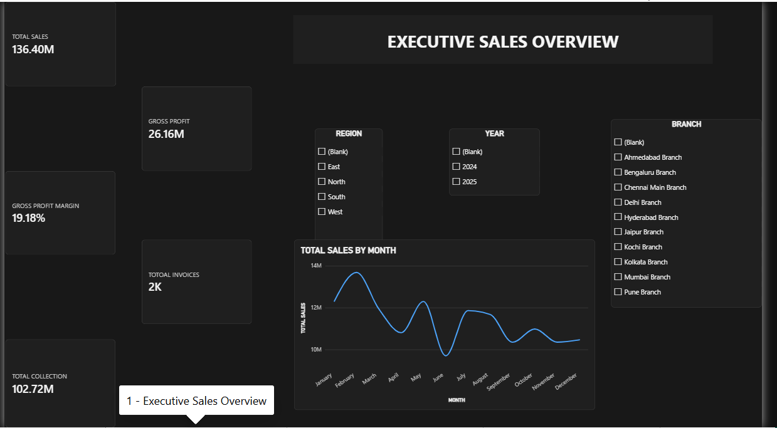
Executive Sales Overview dashboard page
Visual | Type | Fields used
Total Sales, Gross Profit, Gross Profit Margin, Total Invoices, Total Collection | Cards | FactInvoiceLines, FactInvoices, FactPayments measures
Region | Slicer | DimRegion[region_name]
Year | Slicer | DimDate[year]
Branch | Slicer | DimBranch[branch_name]
Total Sales by Month | Line chart | DimDate[full_date] (month level) and Total Sales

Key observations:
- Total Sales is 136.40M, Gross Profit is 26.16M and the margin is 19.18%, from about 2K invoices and 102.72M of collections.
- Monthly sales peak in February at roughly 13.7M and fall to a low of about 9.7M in June.
- Sales recover to about 11.8M in July, then settle between 10.4M and 11M from September to December.
- The branch list shows ten branches: Ahmedabad, Bengaluru, Chennai Main, Delhi, Hyderabad, Jaipur, Kochi, Kolkata, Mumbai and Pune.

5.2 Page 2: Product & Discount Analysis
This page explains which products and categories earn the most and where discounts are concentrated. It has five charts plus Region, Year and Branch slicers.
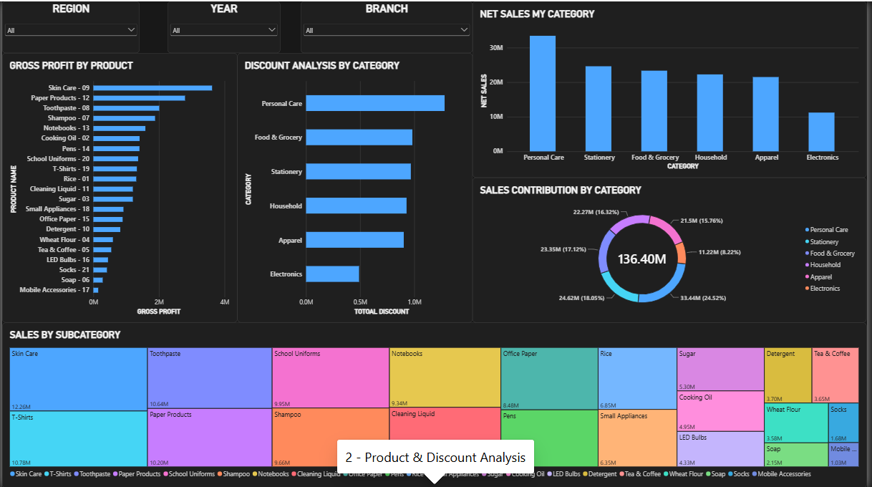
Product & Discount Analysis dashboard page
Visual | Type | Fields used
Gross Profit by Product | Bar chart | DimProduct[product_name], Gross Profit
Discount Analysis by Category | Bar chart | DimProduct[category], Total Discount
Net Sales by Category | Column chart | DimProduct[category], Sum of net_sales
Sales Contribution by Category | Donut chart | DimProduct[category], Total Sales
Sales by Subcategory | Treemap | DimProduct[subcategory], Gross Sales

Key observations:
- Skin Care (about 3.6M), Paper Products (about 2.8M) and Toothpaste (about 2.2M) earn the highest gross profit; Mobile Accessories earns the least.
- Personal Care leads net sales at roughly 33.4M, followed by Stationery (24.6M), Food & Grocery (23.4M), Household (22.3M), Apparel (21.5M) and Electronics (11.2M).
- Personal Care contributes 24.52% of sales (33.44M), Stationery 18.05%, Food & Grocery 17.12%, Household 16.32%, Apparel 15.76% and Electronics 8.22%.
- Personal Care also receives the highest discount (about 1.25M), while Electronics receives the lowest (about 0.5M).
- In the treemap, Skin Care (12.26M), T-Shirts (10.78M), Toothpaste (10.64M), Paper Products (10.20M), School Uniforms (9.95M), Shampoo (9.66M) and Notebooks (9.34M) are the largest subcategories; Mobile Accessories (1.03M) is the smallest.

5.3 Page 3: Customer & Receivables
This page links customer sales to money still owed. A customer table on the left lists invoice amount, ageing bucket and total collection for every customer, with Year, Customer Type, Payment Status and Customer Name slicers on the right.
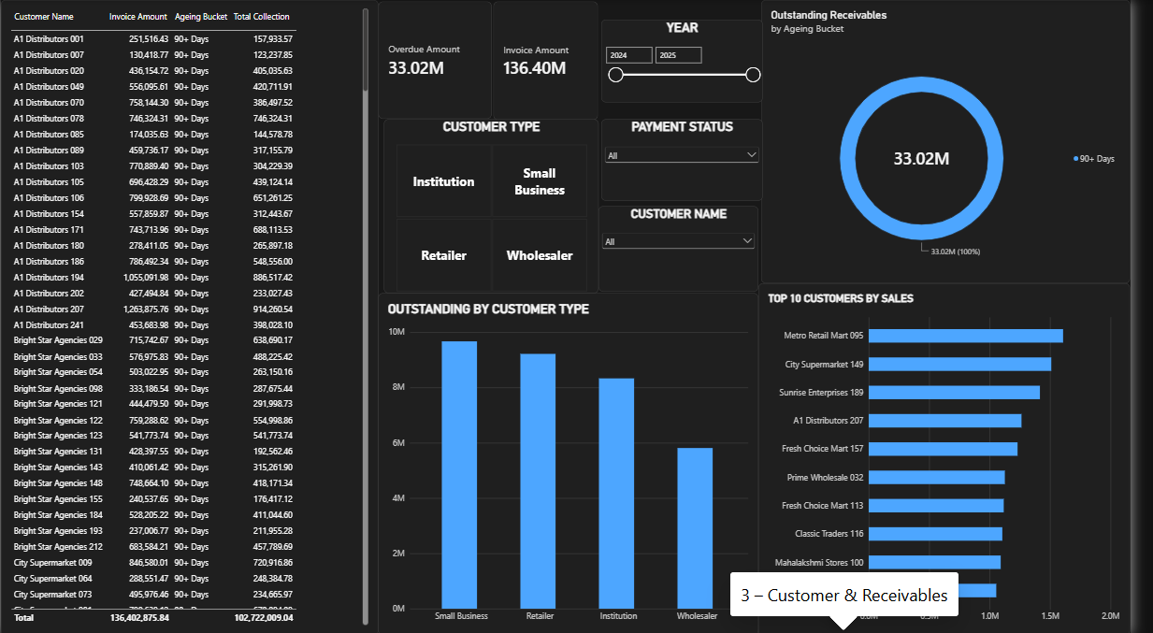
Customer & Receivables dashboard page
Visual | Type | Fields used
Customer table | Table | Customer name, Invoice Amount, Ageing Bucket, Total Collection
Overdue Amount, Invoice Amount | Cards | FactInvoices measures
Outstanding Receivables by Ageing Bucket | Donut chart | Ageing Bucket, Outstanding Receivables
Outstanding by Customer Type | Column chart | DimCustomer[customer_type], Outstanding Receivables
Top 10 Customers by Sales | Bar chart (Top N filter) | DimCustomer[customer_name], Total Sales
Customer Type, Payment Status, Customer Name, Year | Slicers | DimCustomer, FactInvoices, DimDate

Key observations:
- The table total shows invoices of 136,402,875.84 against collections of 102,722,009.04.
- Overdue Amount is 33.02M, and the donut chart places 100% of it in the 90+ Days bucket.
- By customer type, Small Business owes the most (about 9.7M), then Retailer (about 9.2M), Institution (about 8.3M) and Wholesaler (about 5.8M).
- The top customers by sales are Metro Retail Mart 095 (about 1.6M), City Supermarket 149 (about 1.5M) and Sunrise Enterprises 189 (about 1.4M).

5.4 Page 4: Collections & Sales Returns
This page shows how money is received and why goods come back. Three KPI cards sit at the top, with Year, Return Reason, Payment Method and Branch Name slicers.
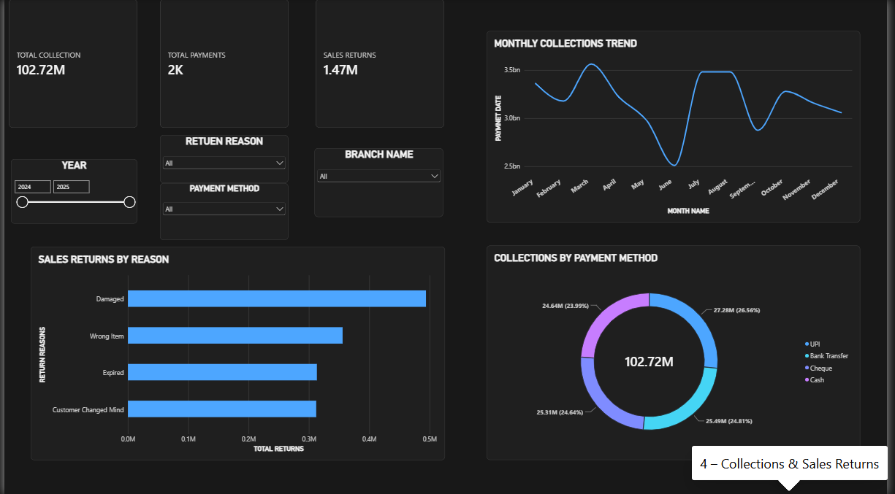
Collections & Sales Returns dashboard page
Visual | Type | Fields used
Total Collection, Total Payments, Sales Returns | Cards | FactPayments, FactSalesReturns
Monthly Collections Trend | Line chart | DimDate[month_name], collections
Collections by Payment Method | Donut chart | FactPayments[payment_method], Total Collection
Sales Returns by Reason | Bar chart | FactSalesReturns[return_reason], Total Returns
Year, Return Reason, Payment Method, Branch Name | Slicers | DimDate, FactSalesReturns, FactPayments, DimBranch

Key observations:
- Total Collection is 102.72M from about 2K payments, and Sales Returns total 1.47M.
- Collections are spread almost evenly across four methods: UPI 27.28M (26.56%), Bank Transfer 25.49M (24.81%), Cheque 25.31M (24.64%) and Cash 24.64M (23.99%).
- Damaged goods are the biggest cause of returns (about 0.49M), followed by Wrong Item (about 0.36M), Expired (about 0.31M) and Customer Changed Mind (about 0.31M).
- The collections trend dips sharply in June and recovers in July and August, which matches the low sales seen in June on Page 1.

5.5 Page 5: Branch & Regional Performance
This page compares branches and regions. Four KPI cards at the top show the number of branches and regions, total sales and gross profit, and City, Region, Branch Name and Year slicers filter the page.
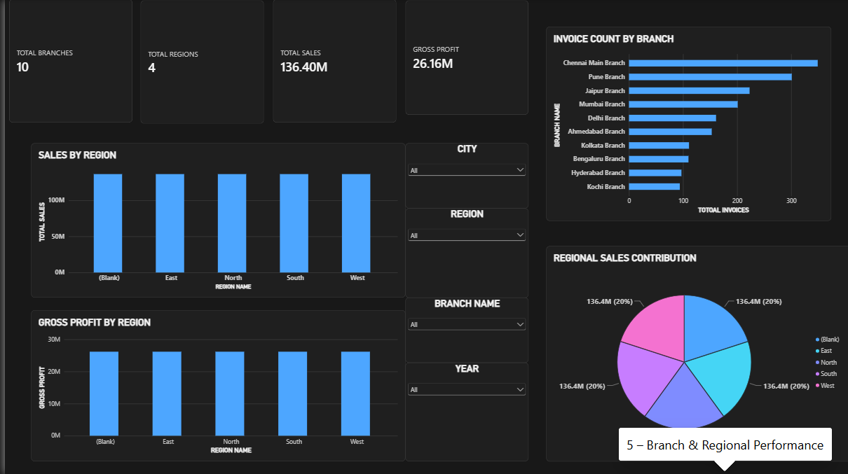
Branch & Regional Performance dashboard page
Visual | Type | Fields used
Total Branches, Total Regions, Total Sales, Gross Profit | Cards | DimBranch, DimRegion, FactInvoiceLines
Sales by Region | Column chart | DimRegion[region_name], Total Sales
Gross Profit by Region | Column chart | DimRegion[region_name], Gross Profit
Regional Sales Contribution | Pie chart | DimRegion[region_name], Total Sales
Invoice Count by Branch | Bar chart | DimBranch[branch_name], Total Invoices
City, Region, Branch Name, Year | Slicers | DimCity, DimRegion, DimBranch, DimDate

Key observations:
- The business has 10 branches in 4 regions, with sales of 136.40M and gross profit of 26.16M.
- Chennai Main Branch has the most invoices (about 345), followed by Pune (about 300), Jaipur (about 220) and Mumbai (about 200). Kochi has the fewest (about 90).
- The region charts show the same value (136.40M sales, 26.16M profit, 20% share) for every region and for a blank region. This means the region filter is not yet splitting the figures and should be corrected before regional conclusions are drawn (see Section 7).

5.6 Page 6: Salesperson Performance & Profitability
This page measures individual salespeople. Four KPI cards show the number of salespersons, total sales, gross profit and invoices. A ranked bar chart, a pie chart, a summary table and a profit chart sit beside them.
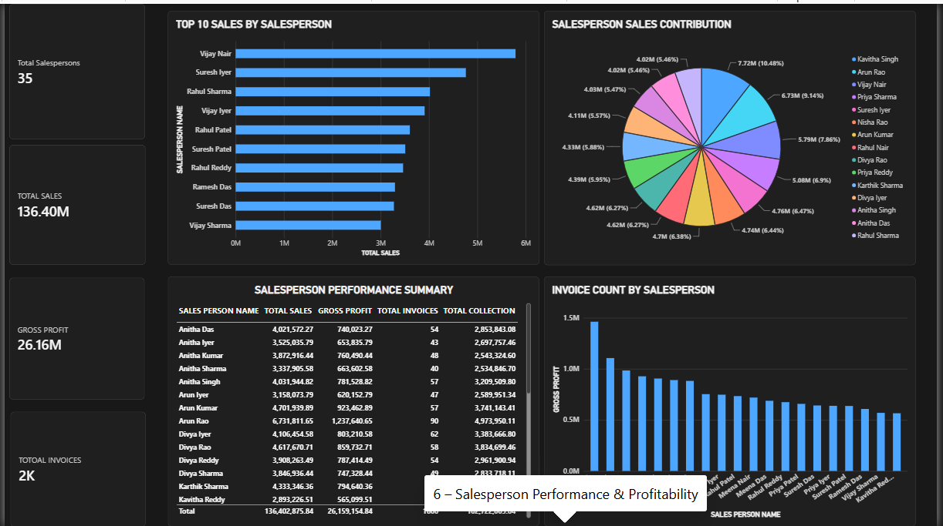
Salesperson Performance & Profitability dashboard page
Visual | Type | Fields used
Total Salespersons, Total Sales, Gross Profit, Total Invoices | Cards | DimSalesperson, FactInvoiceLines, FactInvoices
Top 10 Sales by Salesperson | Bar chart (Top N filter) | DimSalesperson[salesperson_name], Total Sales
Salesperson Sales Contribution | Pie chart (Top N filter) | DimSalesperson[salesperson_name], Total Sales
Salesperson Performance Summary | Table | Name, Total Sales, Gross Profit, Total Invoices, Total Collection
Invoice Count by Salesperson | Column chart | Salesperson name, Gross Profit

Key observations:
- The business has 35 salespersons. The table totals 136,402,875.84 in sales, 26,159,154.84 in gross profit and 102,722,009.04 in collections.
- In the pie chart, Kavitha Singh leads with 7.72M (10.48%), followed by Arun Rao with 6.73M (9.14%) and Vijay Nair with 5.79M (7.86%).
- The Top 10 bar chart starts with Vijay Nair (about 5.8M), then Suresh Iyer (about 4.75M) and Rahul Sharma (about 4.0M); it does not show Kavitha Singh or Arun Rao, so its Top N setting should be checked.
- The column chart titled Invoice Count by Salesperson actually plots Gross Profit, so its title should be corrected.

5.7 Page 7: Overall Performance & Dashboard
The financial summary page combines the main measures in one place, with Year, Region and Branch dropdown slicers. Four KPI cards show Total Sales, Cost of Goods Sold, Gross Profit and Gross Profit Margin.
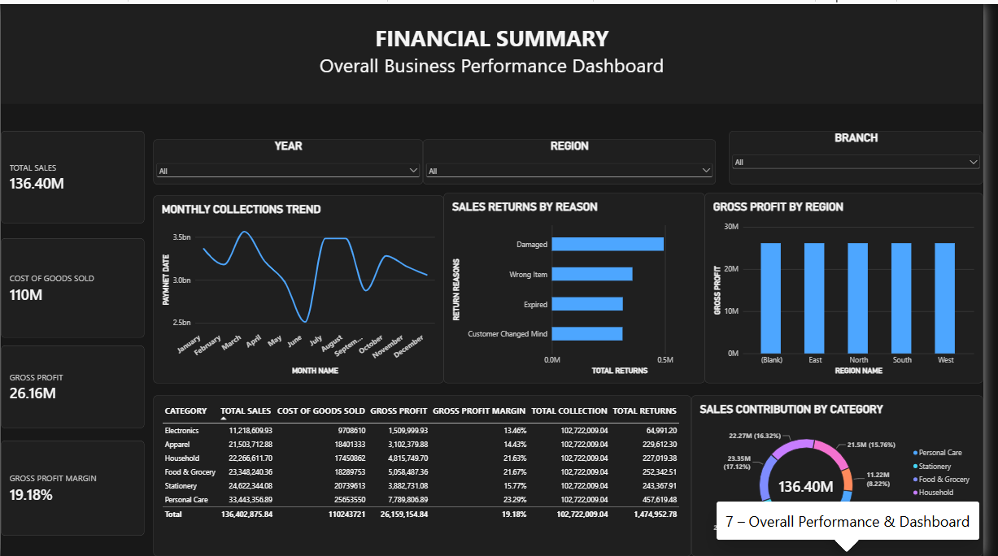
Overall Performance & Dashboard dashboard page
Visual | Type | Fields used
Total Sales, Cost of Goods Sold, Gross Profit, Gross Profit Margin | Cards | FactInvoiceLines
Monthly Collections Trend | Line chart | DimDate[month_name], collections
Sales Returns by Reason | Bar chart | FactSalesReturns[return_reason], Total Returns
Gross Profit by Region | Column chart | DimRegion[region_name], Gross Profit
Category summary | Table | Category, Total Sales, COGS, Gross Profit, Margin, Collection, Returns
Sales Contribution by Category | Donut chart | DimProduct[category], Total Sales

Key observations:
- Sales of 136.40M less cost of goods sold of 110M leaves gross profit of 26.16M, a margin of 19.18%.
- By category, margin is highest for Personal Care (23.29%), Food & Grocery (21.67%) and Household (21.63%), and lowest for Electronics (13.46%) and Apparel (14.43%). Stationery earns 15.77%.
- Personal Care sales are 33,443,356.89 with gross profit of 7,789,806.89; Electronics sales are 11,218,609.93 with gross profit of 1,509,999.93.
- Returns by category range from 64,991.20 for Electronics to 457,619.48 for Personal Care, totalling 1,474,952.78.
- Total Collection shows the same figure (102,722,009.04) against every category, because collections are not linked to product category.

5.8 Page 8: Product Category Details (Drill-through)
This hidden detail page is reached by drilling through from a category on another page. In the screenshot it is filtered to the Stationery category. A back button at the top left returns the user to the previous page.
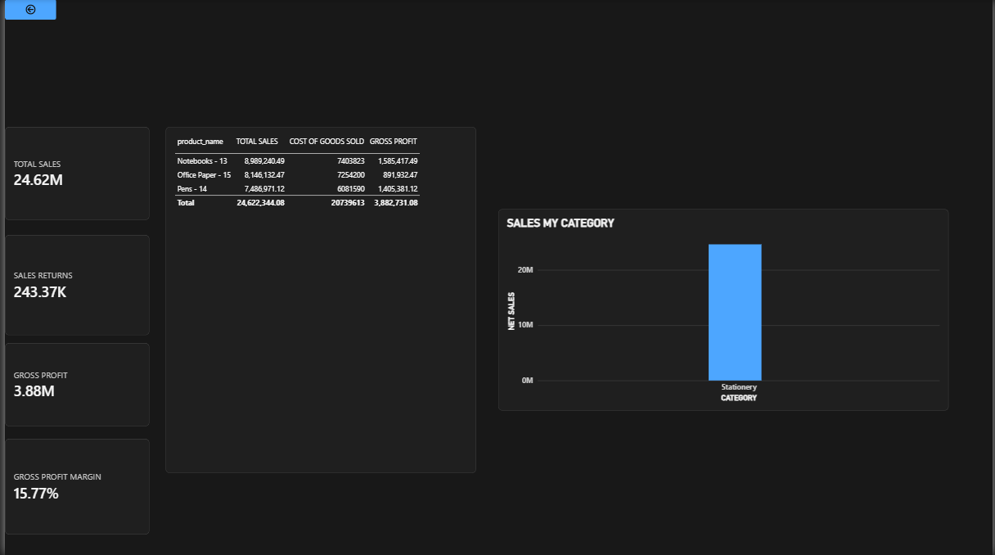
Product Category Details (Drill-through) dashboard page
Visual | Type | Fields used
Total Sales, Sales Returns, Gross Profit, Gross Profit Margin | Cards | FactInvoiceLines, FactSalesReturns
Product table | Table | Product name, Total Sales, Cost of Goods Sold, Gross Profit
Sales by Category | Column chart | DimProduct[category], Sum of net_sales
Back button | Action button | Back navigation
Drill-through filter | Page filter | DimProduct[category]

Key observations:
- Stationery sales are 24.62M with sales returns of 243.37K, gross profit of 3.88M and a margin of 15.77%.
- Notebooks - 13 earns 8,989,240.49 in sales and 1,585,417.49 in gross profit; Office Paper - 15 earns 8,146,132.47 and 891,932.47; Pens - 14 earns 7,486,971.12 and 1,405,381.12.
- Pens give a higher profit than Office Paper from lower sales, so Office Paper has the thinnest margin of the three products.

6. Key Findings
- The business sold 136.40M and earned a gross profit of 26.16M (19.18%) across 2024 and 2025. It collected 102.72M, leaving about 33M overdue.
- Personal Care is the strongest category, with 24.52% of sales and the highest margin (23.29%). Electronics is the weakest, with 8.22% of sales and the lowest margin (13.46%).
- Skin Care, Paper Products and Toothpaste are the most profitable products. Skin Care is also the largest subcategory at 12.26M.
- Sales are highest in February and lowest in June, and collections show the same June dip.
- All outstanding receivables are in the 90+ Days bucket. Small Business and Retailer customers owe the most.
- Collections are well spread across UPI, Bank Transfer, Cheque and Cash, with UPI slightly ahead at 26.56%.
- Damaged goods are the leading reason for returns, so packing and handling deserve attention.
- Chennai Main Branch and Pune handle the most invoices.

7. Conclusion
The Power BI report gives a complete picture of sales, profit, receivables, collections and returns in eight connected pages. Management can start from the executive overview, move to products, customers, collections, branches and salespersons, and drill through to category detail when needed. The report meets the project objectives. Correcting the points in Section 7, especially the region relationship and the collections trend, will make the dashboard ready for regular business use.

